Laser

Overview  
 This course will use the Raspberry Pi to control the laser transmitter to emit laser signals, and show the working status of the infrared emission tube by the LED light on and off.

Experimental Materials

RaspberryPi *1

Breadboard *1

Laser *1

Led *1

Dupont Line

Ready to work  
1. Install python interpreter in your Raspberry Pi system  
2. Install the RPi.GPIO library in your Raspberry Pi system  
3. Install the wiringPi library in your Raspberry Pi system  
See the attached "Installing a Python Interpreter and Corresponding Libraries in a Raspberry Pi System" for details.

Product description

I. Introduction:

A semiconductor laser is a device that generates stimulated emission effect by using a certain semiconductor material as a working substance.Its working principle is to realize non-equilibrium [current](D:/%E7%BD%91%E6%98%93%E6%9C%89%E9%81%93%E8%AF%8D%E5%85%B8/Dict/8.0.0.0/resultui/html/index.html" \l "/javascript:;)-[carrier](D:/%E7%BD%91%E6%98%93%E6%9C%89%E9%81%93%E8%AF%8D%E5%85%B8/Dict/8.0.0.0/resultui/html/index.html" \l "/javascript:;) inversion between the energy band (conductor band and valence band) of semi-conductor material, or the energy band of semi-conductor substance and impurity (acceptor or donor) energy level through a certain excitation method. The number of sons is reversed, and when a large number of electrons in the state of population inversion recombine with holes, stimulated emission occurs.There are mainly three kinds of semiconductor laser excitation methods, namely, electro-injection, optical pump and high-energy electron beam excitation.

The advantages of semiconductor lasers include small size, light weight, reliable operation, low power consumption, and high efficiency. It is Widely used in fiber optic communications, optical discs, laser printers, laser scanners, laser pointers (laser pens), is currently the largest laser production.

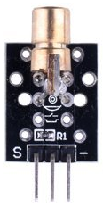

Characteristic parameters

◆Working voltage: 5V

◆Specification: 15*24 mm  
◆ Light source wavelength: 650 nm

◆ Weight: 2.2 g  
◆The module is soldered with a 1KΩ pull-up resistor

◆The pull-up resistor is connected to 5V

Wiring diagram

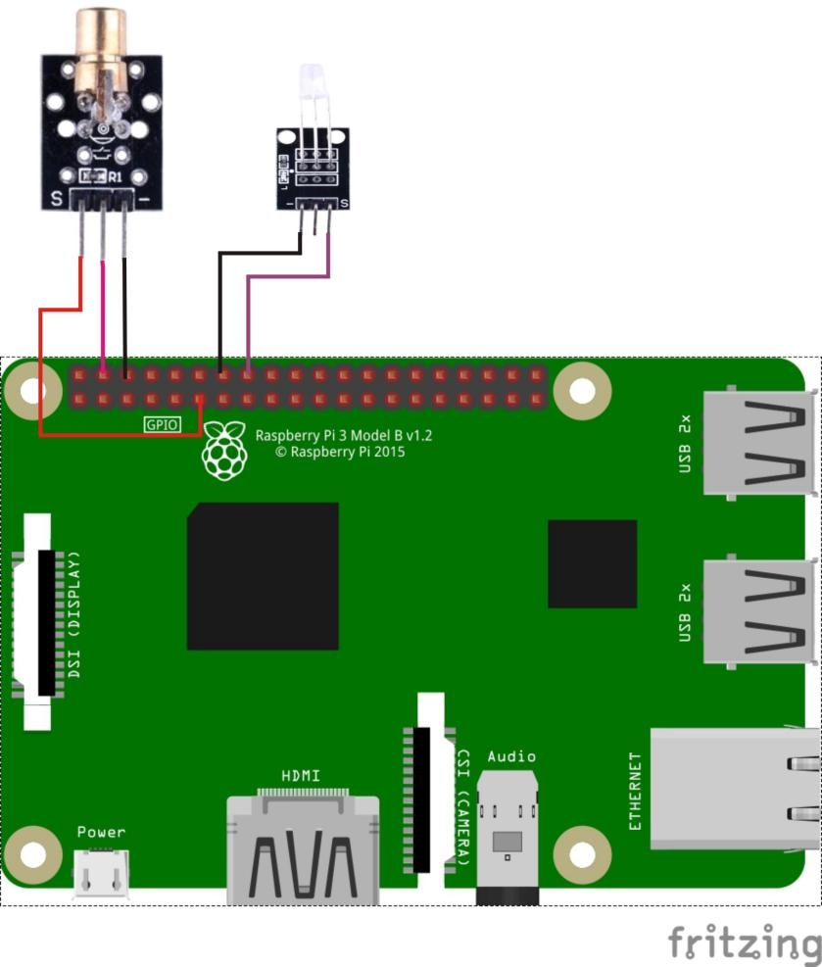

Sample code

1. Python code

#!/usr/bin/env python

import RPi.GPIO as GPIO

import time

LaserPin = 11 # pin11

LedPin = 16

def setup():

GPIO.setmode(GPIO.BOARD) # Numbers GPIOs by physical location

GPIO.setup(LaserPin, GPIO.OUT) # Set LaserPin's mode is output

GPIO.setup(LedPin, GPIO.OUT) # Set LedPin's mode is output

def loop():

while True:

print '...LaserPin on'

GPIO.output(LaserPin, GPIO.HIGH) # LaserPin on

GPIO.output(LedPin, GPIO.HIGH)

time.sleep(0.5)

print 'LaserPin off...'

GPIO.output(LaserPin, GPIO.LOW) # LaserPin off

GPIO.output(LedPin, GPIO.LOW)

time.sleep(0.5)

def destroy():

GPIO.output(LaserPin, GPIO.LOW) # LaserPin off

GPIO.cleanup() # Release resource

if __name__ == '__main__': # Program start from here

setup()

try:

loop()

except KeyboardInterrupt: # When 'Ctrl+C' is pressed, the child program destroy() will be executed.

destroy()

2. C code

#include <wiringPi.h>

#include <stdio.h>

#define LaserPin 0

#define LedPin 4

int main(void)

{

if(wiringPiSetup() == -1)

{

printf("setup wiringPi failed !");

return -1;

}

pinMode(LaserPin, OUTPUT);

pinMode(LedPin, OUTPUT);

while(1)

{

digitalWrite(LaserPin, HIGH);

digitalWrite(LedPin, HIGH);

printf("Laser on....\n");

delay(1000);

digitalWrite(LaserPin, LOW);

digitalWrite(LedPin, LOW);

printf("Laser off....\n");

delay(1000);

}

return 0;

}

Experimental phenomena

With the laser transmitter working, LED light is on and off in circle.